**Week3\_Spring Data JPA - Quick Example**

**Step 1: Create Eclipse Project using Spring Initializr**

### **1.1 Configure Spring Initializr**

1. Navigate to https://start.spring.io/
2. Configure the following settings:
   * **Group**: com.cognizant
   * **Artifact Id**: orm-learn
   * **Description**: Demo project for Spring Data JPA and Hibernate
3. Select Dependencies:
   * Spring Boot DevTools
   * Spring Data JPA
   * MySQL Driver
4. Click **Generate** and download the project as zip

### IMG_256

### 1.2 Import Project into Eclipse

1. Extract the downloaded zip file to your Eclipse Workspace
2. In Eclipse: **File > Import > Maven > Existing Maven Projects**
3. Browse and select the extracted folder
4. Click **Finish**

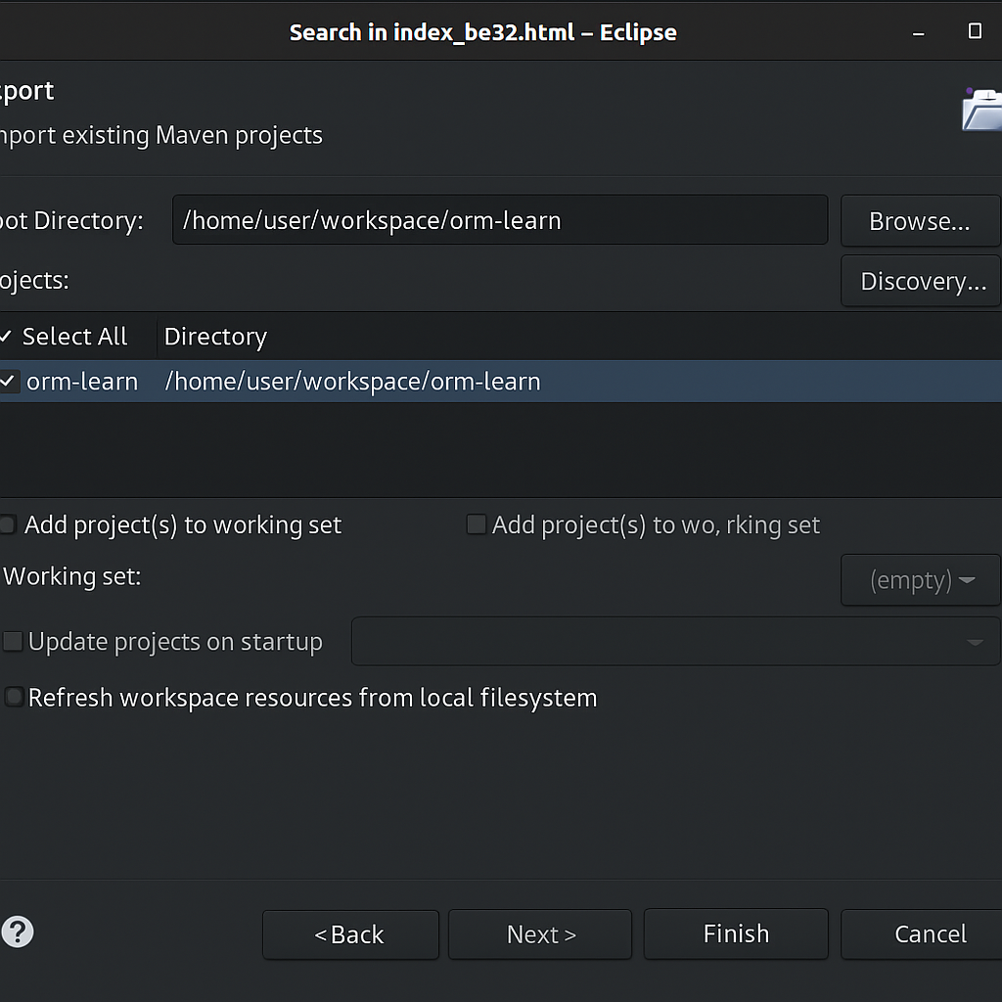

## Step 2: Database Setup

### 2.1 Create MySQL Schema

Execute the following commands in MySQL client:

mysql -u root -p

mysql> create schema ormlearn;

### IMG_256

### 2.2 Create Country Table

create table country(

co\_code varchar(2) primary key,

co\_name varchar(50)

);

### 2.3 Insert Sample Data

insert into country values ('IN', 'India');

insert into country values ('US', 'United States of America');

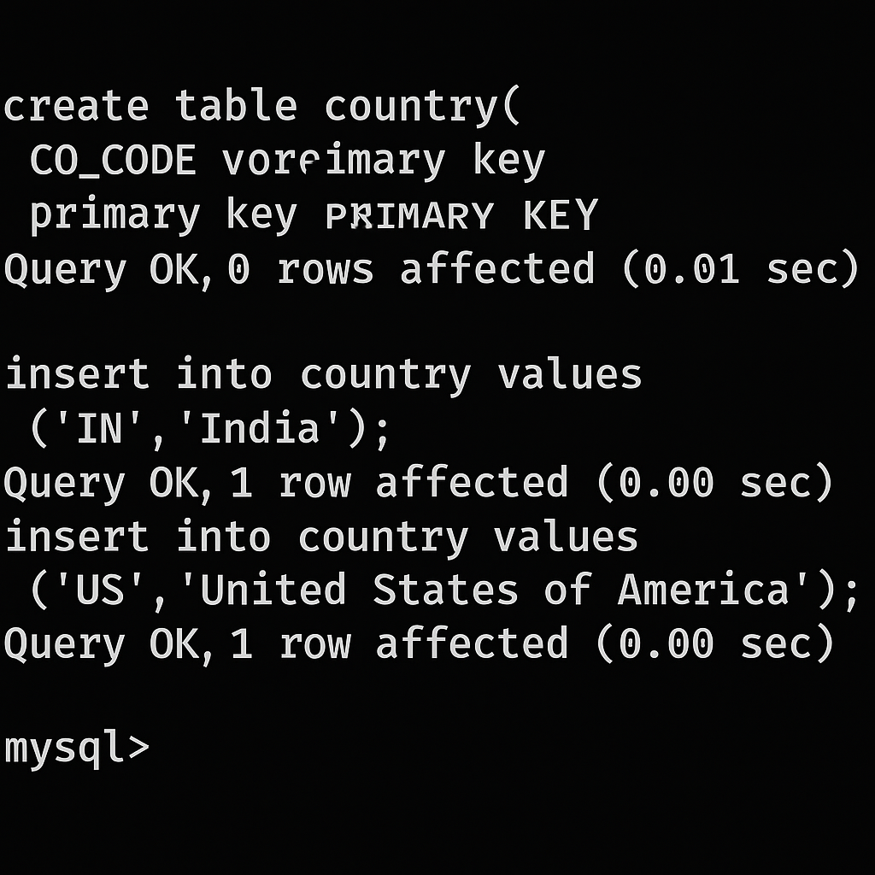

## Step 3: Application Configuration

### 3.1 Configure application.properties

Open src/main/resources/application.properties and add the following configuration:

# Spring Framework and application log

logging.level.org.springframework=info

logging.level.com.cognizant=debug

# Hibernate logs for displaying executed SQL, input and output

logging.level.org.hibernate.SQL=trace

logging.level.org.hibernate.type.descriptor.sql=trace

# Log pattern

logging.pattern.console=%d{dd-MM-yy} %d{HH:mm:ss.SSS} %-20.20thread %5p %-25.25logger{25} %25M %4L %m%n

# Database configuration

spring.datasource.driver-class-name=com.mysql.cj.jdbc.Driver

spring.datasource.url=jdbc:mysql://localhost:3306/ormlearn

spring.datasource.username=root

spring.datasource.password=root

# Hibernate configuration

spring.jpa.hibernate.ddl-auto=validate

spring.jpa.properties.hibernate.dialect=org.hibernate.dialect.MySQL5Dialect

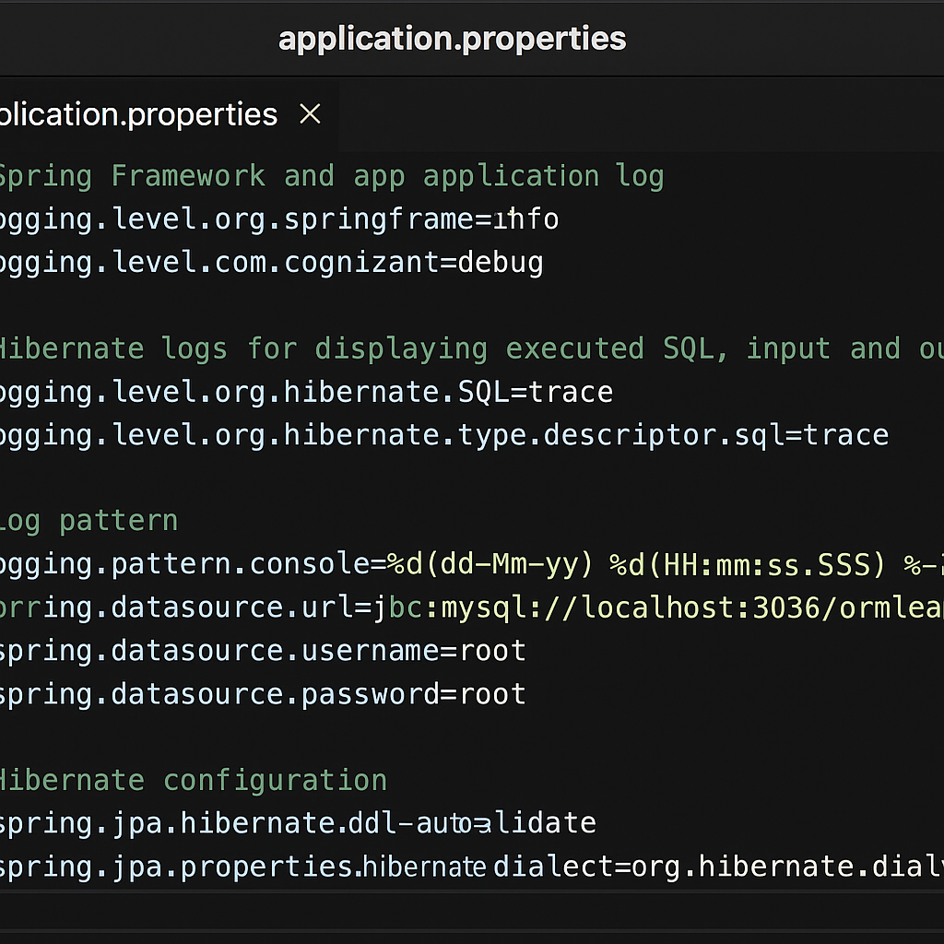

## Step 4: Build and Verify Project

### 4.1 Build Project

Execute the following Maven command:

mvn clean package -Dhttp.proxyHost=proxy.cognizant.com -Dhttp.proxyPort=6050 -Dhttps.proxyHost=proxy.cognizant.com -Dhttps.proxyPort=6050 -Dhttp.proxyUser=123456

### 4.2 Add Logging to Main Method

Modify OrmLearnApplication.java:

import org.slf4j.Logger;

import org.slf4j.LoggerFactory;

private static final Logger LOGGER = LoggerFactory.getLogger(OrmLearnApplication.class);

public static void main(String[] args) {

SpringApplication.run(OrmLearnApplication.class, args);

LOGGER.info("Inside main");

}

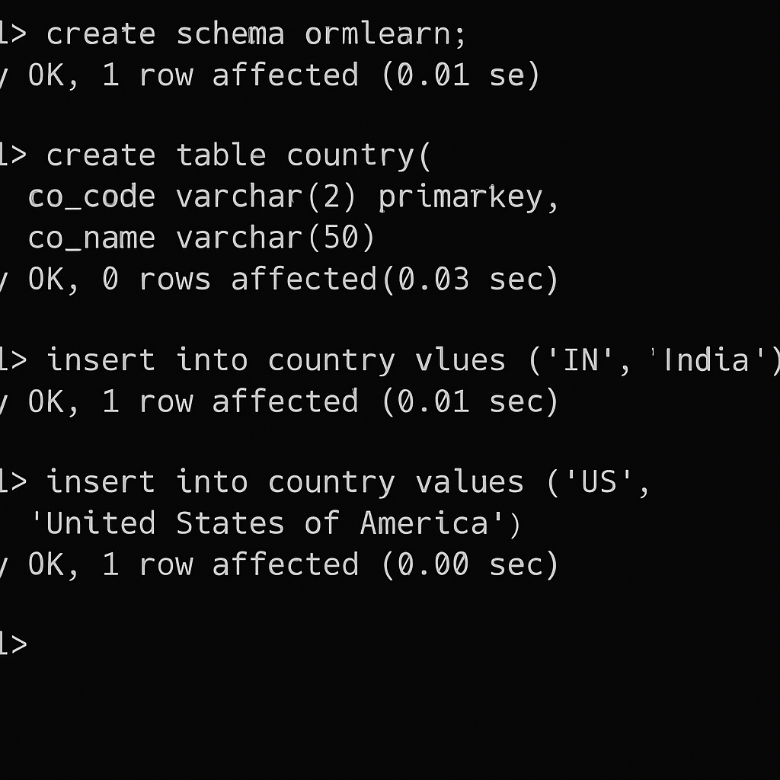

## Step 5: Project Structure Overview

### 5.1 Key Project Components

1. **src/main/java** - Application source code
2. **src/main/resources** - Application configuration files
3. **src/test/java** - Test source code
4. **OrmLearnApplication.java** - Main application class with @SpringBootApplication
5. **pom.xml** - Maven project configuration

### 5.2 @SpringBootApplication Annotation

The @SpringBootApplication annotation provides:

* Auto-configuration capabilities
* Component scanning
* Configuration properties binding

### 

### 5.3 Maven Dependencies

Open **pom.xml** and review the dependency hierarchy:

* Right-click on project → **Maven** → **Show Dependency Hierarchy**

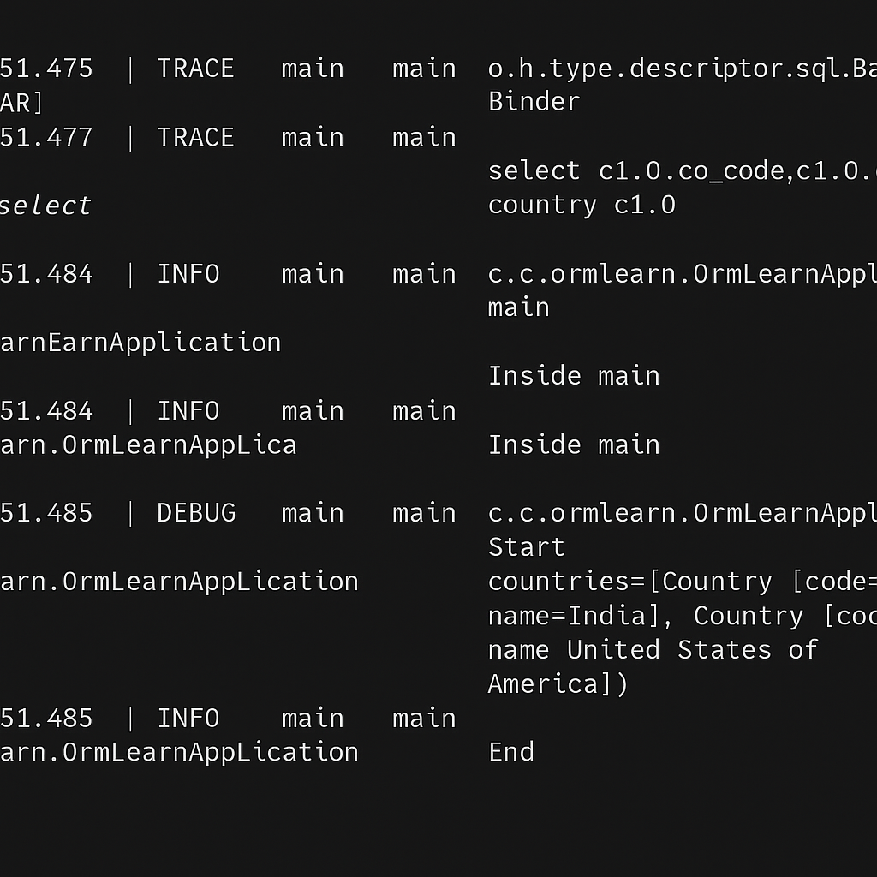

## Step 6: Create Entity Class

### 6.1 Country Entity

Create package: com.cognizant.ormlearn.model

Create Country.java:

package com.cognizant.ormlearn.model;

import javax.persistence.Column;

import javax.persistence.Entity;

import javax.persistence.Id;

import javax.persistence.Table;

@Entity

@Table(name="country")

public class Country {

@Id

@Column(name="co\_code")

private String code;

@Column(name="co\_name")

private String name;

// Constructors

public Country() {}

public Country(String code, String name) {

this.code = code;

this.name = name;

}

// Getters and Setters

public String getCode() {

return code;

}

public void setCode(String code) {

this.code = code;

}

public String getName() {

return name;

}

public void setName(String name) {

this.name = name;

}

@Override

public String toString() {

return "Country [code=" + code + ", name=" + name + "]";

}

}

## Step 7: Create Repository Interface

### 7.1 Country Repository

Create package: com.cognizant.ormlearn.repository

Create CountryRepository.java:

package com.cognizant.ormlearn.repository;

import org.springframework.data.jpa.repository.JpaRepository;

import org.springframework.stereotype.Repository;

import com.cognizant.ormlearn.model.Country;

@Repository

public interface CountryRepository extends JpaRepository<Country, String> {

// JpaRepository provides CRUD operations automatically

}

## Step 8: Create Service Class

### 8.1 Country Service

Create package: com.cognizant.ormlearn.service

Create CountryService.java:

package com.cognizant.ormlearn.service;

import java.util.List;

import org.springframework.beans.factory.annotation.Autowired;

import org.springframework.stereotype.Service;

import org.springframework.transaction.annotation.Transactional;

import com.cognizant.ormlearn.model.Country;

import com.cognizant.ormlearn.repository.CountryRepository;

@Service

@Transactional

public class CountryService {

@Autowired

private CountryRepository countryRepository;

public List<Country> getAllCountries() {

return countryRepository.findAll();

}

}

## Step 9: Testing the Application

### 9.1 Update Main Application Class

Modify OrmLearnApplication.java:

package com.cognizant.ormlearn;

import java.util.List;

import org.slf4j.Logger;

import org.slf4j.LoggerFactory;

import org.springframework.boot.SpringApplication;

import org.springframework.boot.autoconfigure.SpringBootApplication;

import org.springframework.context.ApplicationContext;

import com.cognizant.ormlearn.model.Country;

import com.cognizant.ormlearn.service.CountryService;

@SpringBootApplication

public class OrmLearnApplication {

private static final Logger LOGGER = LoggerFactory.getLogger(OrmLearnApplication.class);

private static CountryService countryService;

public static void main(String[] args) {

ApplicationContext context = SpringApplication.run(OrmLearnApplication.class, args);

countryService = context.getBean(CountryService.class);

LOGGER.info("Inside main");

testGetAllCountries();

}

private static void testGetAllCountries() {

LOGGER.info("Start");

List<Country> countries = countryService.getAllCountries();

LOGGER.debug("countries={}", countries);

LOGGER.info("End");

}

}

## Step 10: Execute and Verify

### 10.1 Run the Application

1. Right-click on OrmLearnApplication.java
2. Select **Run As** → **Java Application**

**Output**

